Online Resources pack
for young people,
children and
families

BBC Learning, Maths, English, etc.  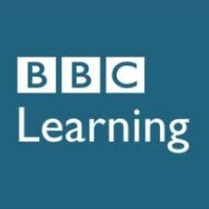 | BBC Learning  https://www.bbc.co.uk/bitesize  https://www.bbc.co.uk/learningenglish/  https://www.bbc.co.uk/teach/skillswise  No TV licence required except for content on BBC iPlayer.  Help with homework, revision and learning. Free videos, step-by-step guides, activities and quizzes by level and subject.
CSCS card/CITB practice | CITB's official App for revision for the Test £5.99:  Apple  Android
Free CITB tests/resources:
https://builderstest.com/
http://www.cscswizard.co.uk/
https://cscstest.org.uk/cscs-mock-test/
https://www.facebook.com/builderstest/

Creative  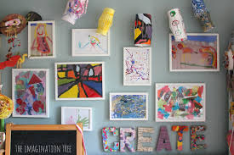 | Blue Peter Badges  https://world-geography-games.com/world.html  If you have a stamp and a nearby post box.
CreativeBug
https://www.creativebug.com/
Creative and Craft ideas and tutorials.

Firstsite Art Gallery
https://firstsite.uk/art-is-where-the-home-is/
Artist Activity Packs
Get creative at home during lockdown.

The Artful Parent
https://www.facebook.com/artfulparent/
Free art activities.

Cooking | 101 COOKBOOKS  https://www.101cookbooks.com/  Vegetarian and vegan recipes.
BBC FOOD
https://www.bbcgoodfood.com/
Budget recipes, chefs, techniques, diets.

BBC FOOD Nadiya Hussain
https://www.bbc.co.uk/food/chefs/nadiya
Recipes from a winner of the Great British Bake Off.

Binging with Babish
https://www.youtube.com/user/bgfilms/playlists
Recipes easy and cheap to cook.

Bon Apetit
https://www.youtube.com/user/BonAppetitDotCom/featured
Recipes that anyone can make at home.

BritishMuslimTV
East Eats West (Recipes)
https://www.youtube.com/playlist?list=PLv2LLinLa14zyRo2XvmL7oIHpNxUhBcGm

BUDGET BYTE$
https://www.budgetbytes.com/
Inexpensive and simple recipes.

Christinatosi
https://www.instagram.com/christinatosi/channel/
Baking recipes, live baking sessions.

Food Wishes
https://www.youtube.com/channel/UCRIZtPl9nb9RiXc9btSTQNw
New recipes every week, playlists based on occasions, meal types.

Halal Chef
https://www.youtube.com/channel/UCMRrH3pUjztiOV8TtQhv_Tw
New recipes ideas, video tutorials.

Halal Home Cooking
https://www.halalhomecooking.com/
Huge collection of recipes.

LOVE FOOD hate waste
https://www.lovefoodhatewaste.com/recipes
A variety of recipes that can be sorted by level of difficulty, cooking time, etc.

Maangchi
https://www.youtube.com/user/Maangchi
Cooking Korean cuisine.

Massimo Bottura
https://www.instagram.com/massimobottura/
Live home cooking with a Michelin star chef.

Minimalist Baker
https://minimalistbaker.com/
A variety of cooking and baking recipes that can be sorted by season, cuisine, diet, simplicity.

My Halal Kitchen
https://myhalalkitchen.com/
Halal food, various cuisines recipes, halal substitutes.

Serious EATS
https://www.seriouseats.com/coronavirus-cooking-guide
Recipes, techniques, coronavirus lockdown cooking guide.

Duke of Edinburgh  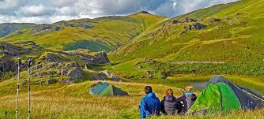 | 2020 DofE Award Summer Programme  https://youth.essex.gov.uk/young-people/the-duke-of-edinburghs-award/funded-dofe-summer-programme/  Open to disadvantaged young people in Essex, aged between 13*- 24 years old. (*13 years olds in current year 9).
Virtual DofE programme
https://youth.essex.gov.uk/young-people/the-duke-of-edinburghs-award/register-to-become-a-virtual-dofe-participant/
Award levels: Bronze, Silver and Gold.
Easy and simple language, pictograms, interactive learning  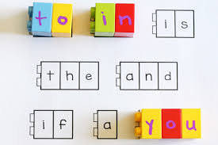 | Some activities here might be suitable for UASC learners? (In order to get used with basic words)  https://www.abcya.com/  https://www.coolmath4kids.com/  https://www.e-learningforkids.org/  https://www.funbrain.com/  https://www.highlightskids.com/  https://kids.nationalgeographic.com/  http://www.literactive.com/Home/index.asp  http://www.mathgametime.com/  https://pbskids.org/  http://www.sciencekids.co.nz/  https://www.seussville.com/  https://www.splashlearn.com/  https://www.starfall.com/h/  https://www.storylineonline.net/  https://www.switchzoo.com/  https://www.turtlediary.com/  https://www.uniteforliteracy.com/
English Language | British Council  https://www.britishcouncil.org/school-resources/find
YouTube – English for You
https://www.youtube.com/user/englishforyoutv

YouTube - Mr. Bruff
https://www.youtube.com/user/mrbruff

YouTube – Trinity College
https://www.youtube.com/user/TrinityVideoChannel/playlists?view=50&sort=dd&shelf_id=3

Family activities  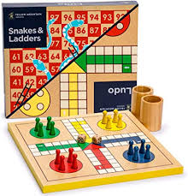 | Good to Know  https://www.goodtoknow.co.uk/family/things-to-do-with-kids-66855  List of fun and cheap activities that families with children or young parents can access mostly for free.
General | ACL Essex  https://aclessex.com/acl-shorts-free-online/  Online sessions to inspire pursuing a passion, find a new hobby or develop existing skills and knowledge.
Alison
https://alison.com/
Huge offer of online courses in various work fields and interests.

BrainPOP
https://www.brainpop.com/
Free education resources specifically for school closures.

CLASS Central
https://www.classcentral.com/
Free online courses that have been developed by several top universities from across the globe, including in ICT and business.

coursera
https://www.coursera.org/
Courses and certificates provided online for free by a variety of universities and companies. The focus is on science, technology, engineering and mathematics.

FutureLearn
https://www.futurelearn.com/courses
Free courses only pay to upgrade if you need a certificate in your name (own account from age 14+ but younger learners can use a parent account).

Khan Academy
https://www.khanacademy.org/
Free online courses, ages 4 – 18.

National Geographic Kids
https://www.natgeokids.com/uk
Resources, activities, information.

OHSC
https://www.oxfordhomestudy.com/free-online-courses-with-certificates
Free courses online with certificates.

Open Learn
https://www.open.edu/openlearn/free-courses/full-catalogue
Free courses on various subjects.

SCHOLASTIC
https://classroommagazines.scholastic.com/support/learnathome.html
Free learn-from-home site with 20+ days of learning and activities.

Shaw Academy
https://www.shawacademy.com/
Usually paid courses / membership, however they are offering a free access for a month.

TEDEd
https://ed.ted.com/lessons?content_type=animations+talks&direction=desc&sort=publish-date&user_by_click=student
Video lessons.

The Crash Courses
https://thecrashcourse.com/
https://www.youtube.com/user/crashcourse
Video crash courses on subjects such as Astronomy, Anatomy, Astronomy, Economics, History, Computer Science, Physiology and many more!

The Kids Should See This
https://thekidshouldseethis.com/
Wide range of cool educational videos.

Twinkl
https://www.facebook.com/artfulparent/
This is more for printouts, and usually at a fee, but they are offering a month of free access to parents in the event of school closures.

Geography | World Geography Games  https://world-geography-games.com/world.html  Geography games!
History | Big History Project  https://www.bighistoryproject.com/home0  Aimed at Secondary age. Multi-disciplinary activities.
IT Skills | Amazon Future Engineer programme  https://amazon.firetechcamp.com/python/  Free virtual codding programme made available due to Covid-19.
Blockly
https://blockly.games/
Learn computer programming skills.

BT Skills for Tomorrow
https://www.bt.com/skillsfortomorrow/index.html
Offers a wide range of free resources anyone can use to help them stay safe, connected an informed online.

Code for Life
https://www.codeforlife.education/
Learning to code.

iDEA Awards
https://idea.org.uk/
Digital enterprise award scheme you can complete online.

Learn My Way
https://www.learnmyway.com/subjects
Free courses to learn digital skills to stay safe and connected.

Scratch
https://scratch.mit.edu/explore/projects/games/
Fun little games created by people around the world.

Tynker
https://www.tynker.com/
Coding for 5+

Languages  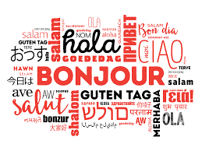 | BBC Languages  http://www.bbc.co.uk/languages/  Courses and phrases, audio and video, vocabulary, pronunciation, grammar, activities and tests.
Transparent Language
https://library.transparent.com/ukessex/game/ng/#/signup/userid?continue=https:~2F~2Flibrary.transparent.com~2Fukessex~2Fgame~2Fng~2F%23~2Fregister~2Fuserid
Need a library card, Student ID or an ID. Wide range of languages.

Libraries  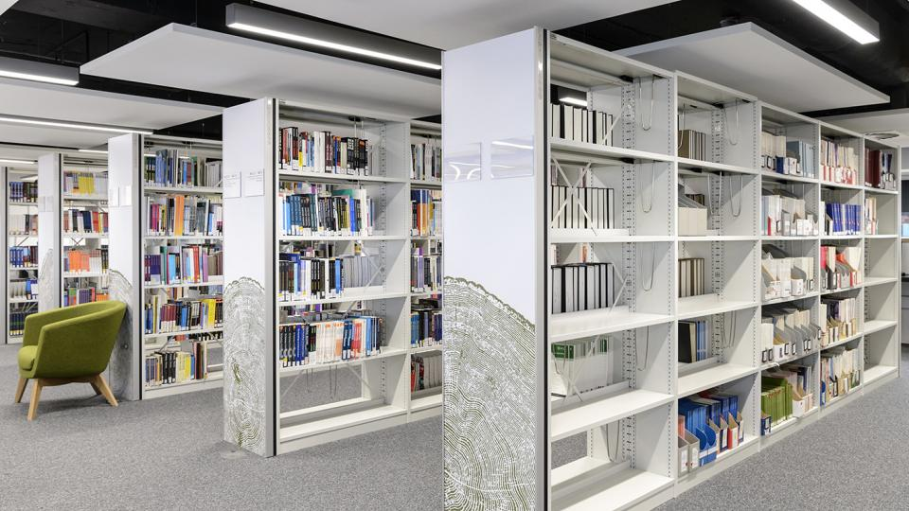 | Amazon  https://blog.aboutamazon.co.uk/in-the-community/amazon-makes-books-video-music-and-more-available-for-free  Stream free audio books, watch free family shows, listen to music. For some of those, an Amazon account might be required.
Essex Libraries
https://libraries.essex.gov.uk/reference-and-courses-online/free-courses/
You can download e books, magazines, comics and audiobooks.
For up to date information visit https://libraries.essex.gov.uk/

Math  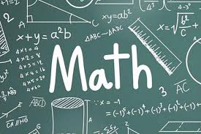 | Best Academy  https://beastacademy.com/  Math Curriculum ages 8 – 13.
dfm
https://www.drfrostmaths.com/index.php
Free Maths online learning.

Museums | Virtual tour of 12 famous museums  https://www.travelandleisure.com/attractions/museums-galleries/museums-with-virtual-tours
Music | ChoirCommunity  https://www.choircommunity.net/blog/distant-sing-a-brand-new-virtual-singing-experience/  Online singing experiences, meet singers from all round the world, interact with them, make suggestions and connections, and even (almost) sing with them.
making music
https://www.makingmusic.org.uk/resource/covid-19-staying-connected
Resources for group music.

The Institute of Contemporary Music Performance
https://www.icmp.ac.uk/blog/free-resources-available-during-covid-19-pandemic
Free resources and tools for musicians.

WHAT HI-FI
https://www.whathifi.com/features/best-live-music-streams-and-virtual-concerts-to-watch-online
Virtual concerts, DJ streams, live gigs and online clubs.

Youth Music Network
https://network.youthmusic.org.uk/resources
https://network.youthmusic.org.uk/dj-lockdown-%E2%80%93-free-activities-and-advice-djs-home
Tools, guidance and resources for music-making.

Revision  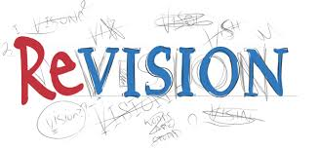 | Collins  https://collins.co.uk/pages/revision-gcse-ages-14-16-collins-gcse-revision-and-practice-flashcards  Free revision cards and tests.
CPG
https://www.cgpbooks.co.uk/resources/free-tests,-tips-and-games
Revision, tests and games.

GetRevising
https://getrevising.co.uk/
Free revision materials at Functional Skills, GCSE, IB or A Level. Study Planner.

SENECA
https://www.senecalearning.com/en-GB/
Free revision materials at GCSE or A Level.

Science  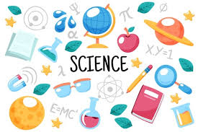 | Fuse School  https://www.fuseschool.org/users/sign_in  They cover core subjects such as Biology, Maths, Chemistry and Physics.
MYSTERY Science
https://mysteryscience.com/
Science lessons.

Sports | AoC Sport  https://www.aocsport.co.uk/coronavirus-resource-hub/  Live videos: https://www.facebook.com/AoCSport1  Virtual timetable of health, wellbeing and fitness sessions.  Guide to keeping active.
Everyone Active
https://www.everyoneactive.com/
Information and advice on exercising from home.
Online membership for those who want to enrol for home workouts, £9.99.

STEM | Crest Awards  https://www.crestawards.org/  Student-led project work in the STEM subjects (science, technology, engineering and maths).  Entry fees starting at £1.
YouTube | Educational YouTube Channels  Free School  https://www.youtube.com/user/watchfreeschool  Geek Gurl Diaries  https://www.youtube.com/user/GeekGurlDiaries  Geography Focus  https://www.youtube.com/channel/UC8HYERScBt-e0kV0fpe0asg  Mike Likes Science  https://www.youtube.com/user/comaniddy  Science Channel  https://www.youtube.com/user/ScienceChannel  Science Max  https://www.youtube.com/channel/UCbprhISv-0ReKPPyhf7-Dtw/featured  SciShow  https://www.youtube.com/user/scishow  SoulPancake  https://www.youtube.com/user/soulpancake  TheBrainScoop  https://www.youtube.com/user/thebrainscoop
UCAS  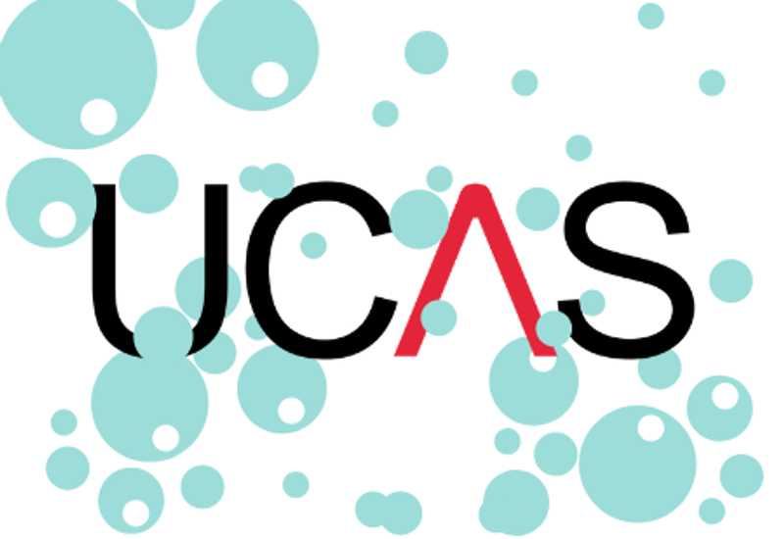 | UCAS  https://www.ucas.com/undergraduate  https://www.ucas.com/careers/buzz-quiz  Home of universities applications, universities information, guides, key dates.
YMCA | YMCA ESSEX  http://www.ymcaessex.org.uk/coronavirus-response/digital-youth-work/  Monday Motivation – Every week new activities to complete at home.  Wellbeing Wednesday’s – Every Wednesday YMCA will connect with young people via Instagram. Join YMCA by searching for @ymcaessex.  Virtual Youth Group – Every Friday at 1.00pm, virtual youth group on ‘Zoom’. Invites will be sent out via text to those who are existing youth club members.

Useful Apps

BBC Learning English  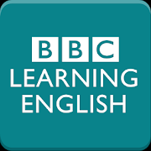  Apple  Android  App for the BBC Learning English site; various English lessons. | Calm Harm  Apple  Android  It helps help people resist or manage the urge to self-harm. It's private and password protected. | Headspace  Apple  Android  Sessions on physical health, personal growth, stress management and anxiety relief.
Houseparty  Apple  Android  Houseparty is a social networking service that enables group video chatting. Make sure the lock feature is used. | Microsoft Teams  Apple  Android  Online meetings, audio and video, file sharing. | MindShift  Apple  Android  MindShift uses strategies based on Cognitive Behavioural Therapy (CBT) to help young adults learn to relax and be mindful and take charge of their anxiety.
NHS  Apple  Android  NHS app lets users search trusted NHS information and advice if you think you have Covid-19 symptoms and provides instant advice or medical help. | Scribd: Audiobooks & eBooks  Apple  Android  Digital library to access audiobooks, eBooks, magazine articles, research documents. Free or subscription access. | Wordfeud  Apple  Android  Like Scrabble, Wordfeud is a puzzle game where you challenge friends to find high scores when landing on a double letters, double word, triple letters or triple word tiles.
Wysa  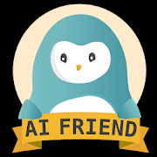  Apple  Android  Friendly and caring chatbot, mood tracker, mindfulness coach, anxiety helper, and mood-boosting buddy. | Yummly Recipes  Apple  Android  Recipes, shopping list, video tutorials. | ZOOM  Apple  Android  Zoom offers screen sharing and quality video and audio tools for online meetings.

